Objectives:

* Writing and reading files.
* Try and catch the statement.
* Intro to GUI Interfaces.

**There are 4 print screens, each worth 25%**

**Project #1** (Based on Chapter 6 Files and Exceptions)



**#1 Print screen the output with the code below here**

Code:

file = open("things.txt", "a")

file.write("Elephant")

file.write("\nApple")

file.write("\nCanada")

file.close()



**#2 Print screen the output with the code below here**

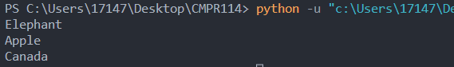

Code:

file = open("things.txt", "r")

content = file.read()

print(content)

file.close()

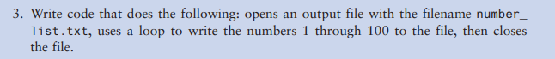

**#3 Print screen the output with the code below here**

Code:

file = open("number_list.txt", "w")

for i in range(1,101):

file.write(f"{i}\n")

file.close()

**Project #2 (**Create a **GUI** application for the following below)

Be sure to create a GUI application using Tkinter

**Use the following numbers inside a text file.**

**1-10**

Example

1

2

3

4

5

6

7

8

9

10

**#4 Print screen the output with code below here**

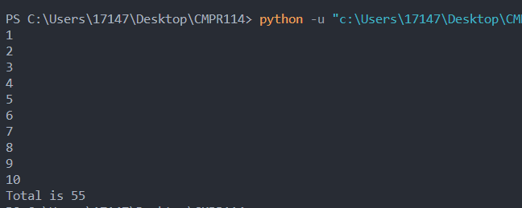

Code:

import tkinter as tk

from tkinter import *

from tkinter import filedialog

def browse_button():

global fullpath

fullpath = filedialog.askopenfilename()

file = open(fullpath, "+r")

content = file.readlines()

# print(content)

total = 0

for line in content:

total += int(line)

file.write(f'Total is {total}')

file.close()

return total

def display_results():

file = open(fullpath, "r")

content = file.read()

print(content)

win = tk.Tk()

win.geometry("300x100")

win.title("Select File")

btnbrowse = tk.Button(win, text="Browse", command=browse_button, font={"Arial", 14})

btnbrowse.pack(padx=10)

tk.mainloop()

display_results()

**Submit this document to Module 3 homework.**